To: | General Purposes Licensing Committee
Date: | 5th February 2024
Report of: | Head of Planning and Regulatory Services
Title of Report: | Miscellaneous Licensing: Fees and Charges for the 2024/25 financial year

Summary and recommendations
Purpose of report: |  | To seek agreement of the licence fees for 2024/25 where the Council has discretion over the level of fee charged
Corporate Priority |  | Enable an inclusive economy and Support Thriving Communities
Policy Framework |  | None
Recommendation(s): That the General Purposes Licensing Committee resolves to:
1. | Agree the licence fees and charges for 2024/25 as set out in Appendix 1 as amended by appendix 2 and recommend them to Council

Appendices
Appendix 1 | Acupuncture, Ear Piercing, Electrolysis & Tattooing, Animal Boarding, Dangerous Wild Animals, Dog Breeding, Pavement Cafes, Pet Shops, Exhibiting Animals, Riding Establishments, Street Trading and Zoos.
Appendix 2 | Draft amended text and amounts for Pavement Licenses and Street Cafes

Introduction

- The purpose of this report is to seek agreement to the licence fees and charges that should apply for 2024/25, for those activities where the Council has discretion. This report does not cover the fees for Licensing Act and Gambling Act activities, which are reported separately to the Licensing and Gambling Acts Committee.

- The fees and charges referred to within this report and found at Appendix 1 relate solely to the functions of the Business Regulation Team and are identical to those contained in the Consultation Budget. Some amendments to the Fees & Charges list text and amounts for Pavement Licenses and Street Café licenses are contained in Appendix 2 and explained in paras. 6-11 below.

- The statutory principle in relation to the setting of fees is that they should be reasonable, proportionate and not exceed the cost of the procedures and formalities of the relevant licensing scheme, including staffing, training, administration, testing, inspections, hearings, and regulation.

- Licence fees set by the Council and administered in the Miscellaneous Licensing function within the Business Regulation Team comprise the following: Acupuncture, Ear Piercing, Electrolysis & Tattooing, Animal Boarding, Dangerous Wild Animals, Dog Breeding, Pavement Cafes, Pet Shops, Exhibiting Animals, Riding Establishments, Street Trading and Zoos.

5. Members are asked to note that overall, the fees have been revised and minor increases applied to cover the Council’s costs, due to inflationary pressures.

Pavement licenses
- In 2020 central Government brought in Pavement Licences under new temporary provisions in the Business and Planning Act 2020 (the 2020 Act). Originally a 12 month-long scheme, the Pavement Licence provisions have subsequently been extended annually three times and currently run until September 2024. As reported in previous years, the mandatory £100 fee set by Government is insufficient to meet pavement licensing service costs. New Burdens temporary funding has been provided to all licensing authorities to help operate this temporary regime.
- The Levelling-up and Regeneration Act 2023 (the 2023 Act) gained Royal Assent on 26th October 2023 and Part 12, Section 229 and Schedule 23 (detailed provisions) together bring in a new, permanent regime for pavement licensing. The Act upholds most of the 2020 Act’s provisions but adding new enforcement powers to address operation without a licence. The licensing authority may require removal of unauthorised furniture, and, in default, remove the unauthorised items and recover their reasonable costs in so doing. Currently only the Highway Authority and Police can do this.
- Parliament recognised that the £100 annual fee under the 2020 Act was insufficient to cover licensing authority costs and the 2023 Act states that fees may be up to £500 or £350 (for premises with an existing Pavement Licence). Similarly, licenses may be granted for up to 2 years, thereby reducing administrative costs, both for licensing authorities and for businesses.
- However, relevant provisions for pavement licenses under the 2023 Act are not yet in force and currently secondary legislation is awaited and until implementing regulations come into force, the 2020 regime and fees remain in place. Appendix 2 therefore contains two proposed Fee sets for Pavement Licenses in 2024-5: the existing Government-set £100 fee; and the new maximum fees allowed under the 2023 Act (stated in para. 7), which would come into effect with the implementing regulations.
Street Café Licenses
- Street Café licenses made under the Highways Act 1980 pre-date the temporary pavement licensing regime and originally were the only means for a business lawfully to put street furniture on the public highway (including pavements). One difference between the two regimes is that planning permission is required for a Street Café Licence. Fees for Street Café Licenses are not set by central Government and the Council has discretion. The Levelling-up and Regeneration Act 2023 does not repeal the Street Café provisions under the Highways Act 1980. Businesses may still apply for a new or renewed Street Café Licence after the new pavement licence regime comes into effect.
- In Oxford there currently are 7 Street Café Licenses and 90 Pavement Licenses in place. Given the enhanced powers being brought in under the 2023 Act for pavement licence controls and also the efficiencies in administration time already noted, it follows that businesses should be encouraged to utilise the newer street furniture provisions instead of the pre-existing ones. Since Street Café Licence fees are discretionary, it also follows that a licensing authority may seek to further encourage business towards the pavement licence regime by ensuring that Street Café Licenses cost at least as much.
- At its February 2023 meeting the General Purposes Licensing Committee agreed that Street Café Licenses should attract a fee of £100, this being consistent with the temporary pavement licence fee in place at the time. A further recommendation was to apply three new fees, each staged to reflect the number of tables being requested, these fees taking effect if the temporary pavement licence regime under the 2020 Act was not extended into 2024. Both recommendations were approved by Council on 16th April 2023.
- As reported in para. 6, the temporary pavement licence provisions were extended, so Street Café Licence fees should have remained at £100 for the year 2023-24. Unfortunately, due to an administrative error, the staged fees were not correctly depicted as a contingency measure in the published version of the Fees & Charges. This error was carried forward into the Consultation Budget version of the 2024-2025 proposed Fees & Charges list, attached at Appendix 1.
- Given that the 2023 Act will bring in a replacement pavement licencing regime and fee structure when the provisions relating to it come into force, it is recommended that Street Café licence fees are increased at the same time. This could be put in place in advance of the pavement licence fee changes or could be brought in at a date consistent with that set by the pavement licence implementing regulations. Appendix 2 to this Report shows how these two options could be depicted in the Fees & Charges list.
- Members are therefore requested to decide:
  - Whether to approve the proposed Fees & Charges for Miscellaneous Licensing Services, with the exception of Pavement Licenses and Street Café Licenses, as set out in Appendix 1
  - Whether to set future Fees under the new pavement licence provisions in the Levelling-Up and Regeneration Act 2023 (when they come into force) at the upper limits of £500 and £350, as set out in Appendix 2
  - Whether to continue to charge £100 for Street Café Licenses, or to increase the fees to match those in b. above.
  - Whether to apply any changes made in c. above from 1st April 2024 or from a date consistent with that set by the pavement licence implementing regulations.

Legal issues
- The power to levy fees is contained in the legislation relevant to each function or in the Local Government Act 2003 in relation to discretionary services. Fees and charges should reasonably represent the costs of carrying out the function.

Report author | David Stevens
 | Principal Lead Officer, Business Regulation Team
 | Regulatory Services and Community Safety
 | 01865 252556
 | dstevens@oxford.gov.uk

Appendix 1: Fees & Charges for 2024/2025 applicable to the Miscellaneous Licensing functions within the Business Regulation Team as presented to Cabinet on 13/12/2023.
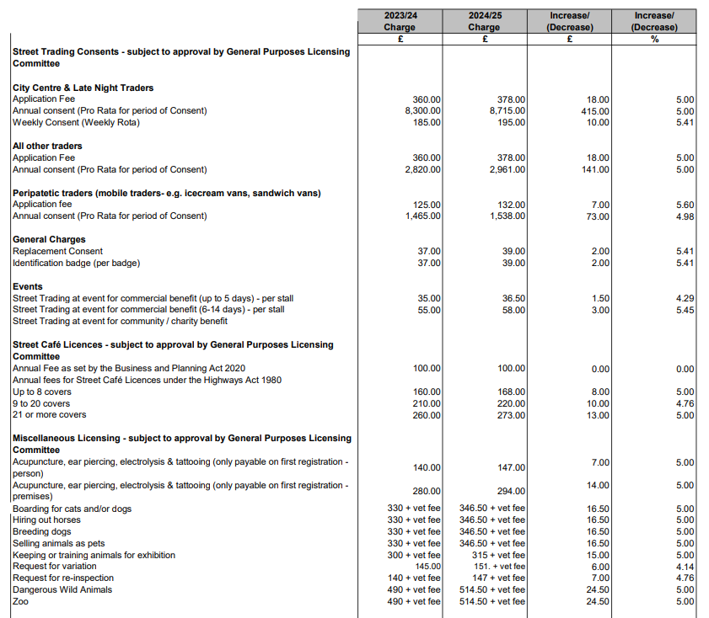

Appendix 2: Draft amendments to the Fees & Charges list in respect of Pavement licenses and Street Café Licenses
 | 2023/24 charge | 2024/25 charge | Increase  (decrease) | Increase (decrease)
 | £ | £ | £ | %
Pavement Licenses – mandatory Annual Fee as set by the Business and Planning Act 2020 | 100 | 100 | 0.00 | 0.00
Pavement Licenses – subject to approval by General Purposes Licensing Committee  Fee for new application for up to 2 years SUBJECT TO PENDING LEGISLATION |  | 500 | NA | NA
Pavement Licenses – subject to approval by General Purposes Licensing Committee  Fee for renewal application for up to 2 years SUBJECT TO PENDING LEGISLATION |  | 350 | NA | NA
Street Café Licences - subject to approval by General Purposes Licensing Committee
Annual fee for Street Café licence under Highways Act 1980
Annual Fee Option 1 | 100 | 100 | 0.00 | 0.00
Annual Fee Option 2 (new licence) |  | 200
Annual Fee Option 2 (existing licence) |  | 275

